C# to display the pattern like a diamond. The pattern is as follows :

\*

\*\*\*

\*\*\*\*\*

\*\*\*\*\*\*\*

\*\*\*\*\*\*\*\*\*

\*\*\*\*\*\*\*

\*\*\*\*\*

\*\*\*

\*

C# Sharp to find the prime numbers within a range of numbers.  
Test Data :  
Input starting number of range: 1  
Input ending number of range : 50  
Expected Output :  
The prime number between 1 and 50 are :  
2 3 5 7 11 13 17 19 23 29 31 37 41 43 47

C# Sharp to display the such a pattern for n number of rows using a number which will start with the number 1 and the first and a last number of each row will be 1

1

121

12321

C# Sharp to display the number in reverse order.

Test Data :  
Input a number: 12345  
Expected Output :  
The number in reverse order is : 54321

C# Sharp to check whether a number is a palindrome or not.    
Test Data :  
Input a number: 121  
Expected Output :  
121 is a palindrome number.

C# Sharp to find the number and sum of all integer between 100 and 200 which are divisible by 9.   
Expected Output :  
Numbers between 100 and 200, divisible by 9 :  
108 117 126 135 144 153 162 171 180 189 198  
The sum : 1683

C# Sharp to convert a binary number into a decimal number without using array, function and while loop

Test Data :  
Input a binary number :1010101  
Expected Output :  
The Binary Number : 1010101  
The equivalent Decimal Number : 85

C# Sharp program to find HCF (Highest Common Factor) of two numbers.    
Test Data :  
Input 1st number for HCF: 24  
Input 2nd number for HCF: 28  
Expected Output :  
HCF of 24 and 28 is : 4

C#Sharp program to display alphabet pattern like A with an asterisk.

Reversed string is:Display the pattern like 'A' with an asterisk:

---------------------------------------------

\*\*\*

\* \*

\* \*

\*\*\*\*\*

\* \*

\* \*

\* \*

\* \*

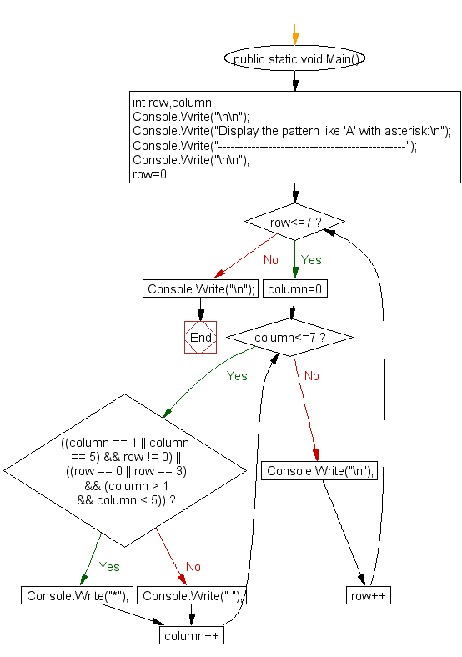

C#Sharp program to display alphabet pattern like D with an asterisk.

Display the pattern like 'D' with an asterisk:

---------------------------------------------

\*\*\*\*

\* \*

\* \*

\* \*

\* \*

\* \*

\*\*\*\*